1) Chat App Redesign: Create a Wireframe and redesign any popular chat app.
Design Process:
1. Frame Setup
- Selected Android Compact frame.
- Added status bar.
2. Header Design
- Create a header container.
- Add a WhatsApp branding text.
- Include utility icons.
3. Body Structure
- Implement a search container with icon and placeholder text.
- Create filter buttons section with three options:
- "All", "Unread" and "Groups" buttons.
4. Contact List Elements
- Design contact container with:
- Profile picture
- Contact name
- Time indicator
- Last message preview.
- Status indicators (pinned, etc.)
- Duplicate and customized for multiple conversations
5. Navigation Bar
- Create bottom navigation with four sections:
- Chats (active, highlighted in green)
- Updates, Communities, and Calls (inactive)
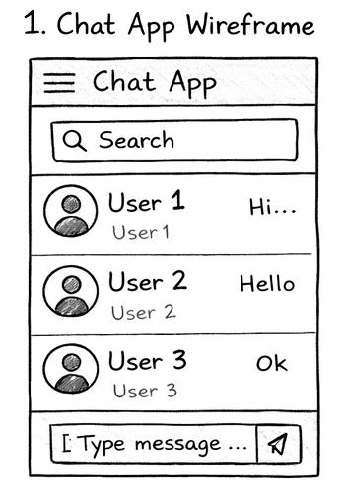

2) Food App: Create a wireframe, Design and Prototype the UI Pages for the food application.
Design Process:
- Base Setup
- Use Android Compact frame.
- Add a status bar.
2. Navigation Structure
- Create a top navigation bar.
- Implement a main navigation options: Delivery, Dining, Nightlife, and Blinkit.
3. Location & Search Elements
- Design a location container with:
- Location icon
- Place name
- Address text with dropdown arrow
- Create search bar.
- Add a veg toggle switch.
4. Category Navigation
- Implement a horizontally scrollable food type container.
- Add category icons with labels (Fast Food, etc.).
5. Filter System
- Create filter buttons.
- Include common filters.
6. Restaurant Listings
- Design restaurant cards with:
- Restaurant image
- Name and ratings
- Cuisine tags and estimated delivery time
- Special offer indicators
7. Restaurant Detail Page
- Create restaurant header with navigation options.
- Implement rating, distance, and timing information.
- Add offers section with horizontal scroll.
- Design menu section with categorized food items.
8. Prototype Connections
- Connect restaurant cards to detail page.
- Add back button functionality to return to main scre
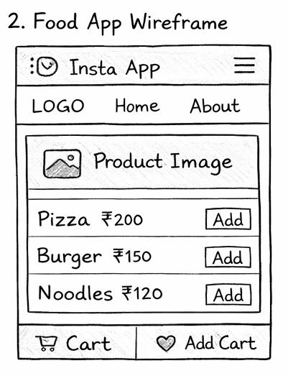

3) Social Media App: Create a wireframe, Design and Prototype social media photo sharing app.
Design Process:
Home Screen Elements:
1. Branding Container
- Instagram logo with dropdown.
- Notification and messaging icons.
2. Stories Container
- "Your Story" with add button.
- User stories with gradient outlines.
3. Post Structure:
- Header with profile picture, username and options
- Image container
- Interaction buttons (like, comment, share, bookmark)
- Caption and comments section
4. Navigation Bar
- Home, Search, Create, Reels, Profile icons
Profile Page Elements:
1. Profile Header
- Back button, username, options menu
2. Profile Information
- Profile picture
- Posts/Followers/Following counts
- Bio text
- Action buttons (Follow, Message, Add)
3. Content Navigation
- Grid view. Reels, Tagged tabs
4. Posts Grid
- 3-column layout
Interactive Prototype
- Connect profile navigation between home and account pages.
- Implement navigation between sections.
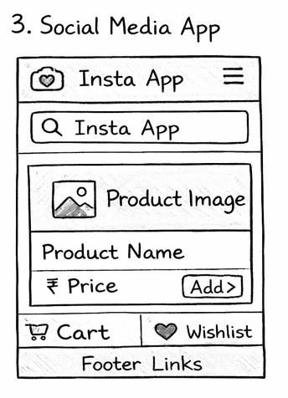
4)Product Website: Design and prototype a product website page. Create web pages and rollovers for the web pages.
Design Process:
Navigation Elements:
1. Navigation Bar
- Google logo.
- Product category links (Phones, Earbuds, etc.).
- Search, Cart, and Profile icons.
- Set to fixed position for scrolling.
Main Content Sections:
1. Hero Section
- Gradient heading: "Oh hi, Gemini".
- Product subheading and interactive "Browse Phones" button.
- Featured Pixel devices image.
2. Recommendations Section
- "Our Top Recommendations" heading.
- Horizontal scrollable product container.
- Individual product cards with:
- Product image on light background
- "New" tag where applicable
- Product name in bold
3. Product Showcase
- "New. Now. Wow." Heading.
- Wrapped layout of varying-sized product containers:
- Large containers for Pixel phones
- Wide container for Pixel Fold
- Tall containers for wearables
- Product description and "Learn More" button
Interactive Elements:
1. Button Components
- Browse Phones button with hover state
- Learn More button with hoverstate
2. Scrolling Behavior
- Vertical overflow for main page
- Horizontal overflow for product recommendation carousel
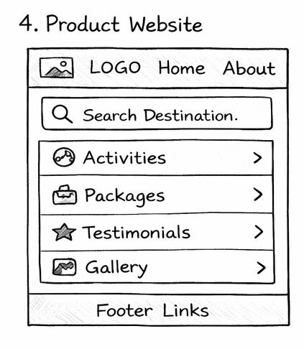
5) Travel Agency Website: Create a wireframe, Design and prototype the UI for the website including design a for Home Page with search bar, Activities page, Client Testimonial Page, Image Gallery.
Design Process:
Navigation Elements:
1. Navigation Bar
- Fixed position navigation bar with Travel Advisor logo.
- Main navigation buttons (Discover, Tips, Review, Forums).
- Secondary buttons (Currency, Sign in).
- Secondary navigation bar with service categories (Search All, Hotels,Things to do, etc.).
Home Page Components:
1. Hero Section
- Search bar with icon and button.
- "Plan your kind of trip" call-to-action.
- Al trip builder feature highlight.
2. Destinations Section
- "Explore the world's most stunning seasides heading.
- Grid display of featured destinations.
- Gradient overlay on destination images for text legibility.
Explore Page Components:
1. Directory Structure
- Breadcrumb navigation showing current location.
- Page heading "Best of the Best Beaches in the World".
2. Featured Beach Section
Hero image with gradient overlay, Badge and awards information, Location details with icons.
3. Review Section
- Rating display, Review cards with user comments, User identification elements.
Interactive Elements:
- Expandable search bar with popular destinations suggestions.
- Connection between pages using prototype links:
- World destinations card links to Explore page.
- Logo links back to Home page.
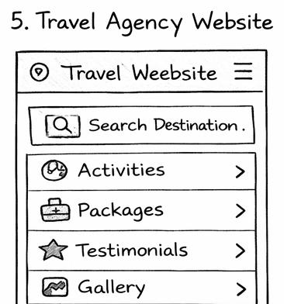
6) UI/UX Designer Portfolio Design: Create a wireframe, Design and prototype a Ul for a portfolio including design for About page, Work showcase page, Blog page, contact page.
Design Process:
1. Homepage Implementation
- Design hero section with name, title and brief introduction.
- Add navigation menu with smooth scrolling functionality.
- Implement a skills section using icons or progress bars.
- Create a featured projects preview grid
2. Project Showcase
- Design project cards with:
- Featured image or screenshot
- Project title and brief description
- Technologies/tools used
- Call-to-action button linking to case study
3. About & Contact Sections
- Create an about section with professional photo and biography.
- Add downloadable resume option.
- Implement contact form with validation.
- Include social media links and professional networks.
4. Interactive Elements
- Add hover effects to project cards and navigation items.
- Implement smooth page transitions.
- Create loading animations for images and content.
- Add subtle scroll-triggered animations.

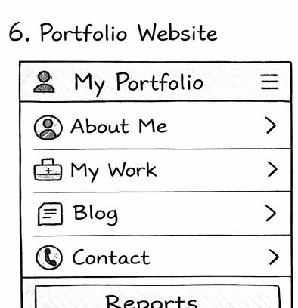
7) Dashboard Design: Create a wireframe, Design and Prototype Dashboard UI page, add some Dashboard details, statistics and graphs, Add dropdown options for some dashboard details.
Design Process:
Layout Structure
Desktop frame with vertical layout.
- Header Section
- Horizontal layout with welcome message and user name.
- Action buttons (Calendar selector, Export button).
Statistics Overview
1. Key Metrics Cards
- Four equal-width cards showing critical data points.
- Each card includes metric title and value, percentage change indicator.
2. Revenue Overview
- Line chart with header with title and time period dropdown.
- Monthly trend visualization.
3. Traffic Sources
- Donut chart with visual distribution of traffic channels.
- "Last Week" filter option.
Detailed Data Sections
1. Top Products:
- Card showing best-performing items
- Each product displayed with:
- Product name and sales data.
- Progress bar indicating performance.
2. User Demographics:
Regional distribution with bar chart Percentage breakdown by location.
3. Recent Activities
- Timeline-style interface.
- Activity description and timestamp.
- Action buttons for follow-up tasks.
- "View All link for accessing complete history.

8) E-Commerce Website: Create a wireframe, Design and prototype Web pages including product category pages (example: mobiles, gaming consoles, Speakers), product pages in each category, buynow page, add to cart page
Objective
To create wireframes, design, and prototype web pages of an E-Commerce website including:
Product Category Pages (Mobiles, Gaming Consoles, Speakers)
Product Detail Pages
Add to Cart Page
Buy Now Page
Tools Required
Figma (UI/UX Design Tool)
Web Browser (Chrome)
Theory
Wireframing is the process of creating a basic layout of a webpage. It helps visualize structure before designing.
Prototyping allows interaction between pages (navigation, buttons, links).
E-commerce websites consist of:
Home Page
Category Page
Product Page
Cart Page
Checkout Page
Procedure
Step 1: Open Figma
Go to Figma Official Website⁠�
Login → Click New Design File
Step 2: Create Frame
Select Frame Tool (F)
Choose Desktop size (e.g., 1440 × 1024)
Wireframes
1. Home Page Wireframe
-------------------------------------------------
| Logo | Search Bar | Login | Cart |
-------------------------------------------------
| Banner / Offers |
-------------------------------------------------
| Categories: |
| [Mobiles] [Gaming Consoles] [Speakers] |
-------------------------------------------------
| Featured Products |
-------------------------------------------------
| Footer |
-------------------------------------------------
2. Category Page (Mobiles / Gaming / Speakers)

-------------------------------------------------
| Filter | Product List |
| | [Product Image] Price Add to Cart |
| | [Product Image] Price Add to Cart |
-------------------------------------------------
3. Product Page

-------------------------------------------------
| Product Image | Product Details |
| | Name |
| | Price |
| | Description |
| | [Add to Cart] [Buy Now] |
-------------------------------------------------
4. Add to Cart Page

-------------------------------------------------
| Product List |
| Name | Price | Quantity | Remove |
-------------------------------------------------
| Total Price |
| [Proceed to Checkout] |
----------------------------------5. Buy Now / Checkout Page

-------------------------------------------------
| Address Details |
| Payment Method |
| Order Summary |
| [Place Order] |
-------------------------------------------------
Design Steps in Figma
Use Shapes (Rectangle, Text) to create layout
Add colors, fonts, icons
Import product images
Use Auto Layout for alignment
Maintain consistency in spacing and design
Prototype Steps
Click Prototype Tab
Connect:
Category → Product Page
Product → Add to Cart
Cart → Checkout
Set interaction:
On Click → Navigate To
Click Present to preview
Result
Successfully designed and prototyped an E-Commerce website in Figma with:
Category Pages
Product Pages
Cart System
Checkout Flow
Conclusion
The experiment helped understand UI/UX design, wireframing, and prototyping concepts using Figma for real-world applications like E-commerce platforms.
Experiment Title
Design and Prototype an Educational Website using Figma
Objective
To create wireframes, design, and prototype an educational website including:
Homepage (with footer)
About Us Page
Programs Page (with dropdown)
Instructors Page
Pricing Page
Payments Page (with radio buttons)
Tools Required
Figma
Web Browser (Chrome)
Theory
Wireframing is a basic visual guide representing the structure of a website.
UI Design focuses on layout, colors, typography, and user interaction.
Prototyping connects different pages and simulates real-time navigation.
Educational websites include structured navigation such as:
Course listings
Instructor details
Pricing plans
Secure payment systems
Procedure
Step 1: Open Figma
Go to Figma Official Website⁠�
Login → Click New Design File
Step 2: Create Frames
Use Frame Tool (F)
Select Desktop size (1440 × 1024)
Create separate frames for each page
Wireframes
1. Homepage Wireframe
Header: Logo | Home | About | Programs | Instructors | Pricing | Login
Banner section with heading and CTA button
Features section (icons + text)
Footer:
About links
Quick links
Contact details
2. About Us Page
Company introduction
Mission and Vision
Image section
Footer
3. Programs Page (Dropdown Design)
Programs button with dropdown:
Engineering
Management
Data Science
Design
Languages
Program cards:
Image
Title
Description
4. Instructors Page
Instructor cards:
Photo
Name
Expertise
Social icons
5. Pricing Page
Plans:
Basic
Standard
Premium
Each includes:
Price
Features
Select Button
6. Payments Page (Radio Buttons)
Select Payment Method:
Credit/Debit Card
PayPal
UPI
Net Banking
Wallet
Input fields:

Cardholder Name
Card Number
Expiry Date
CVV
Button: Pay Now
Design Steps
Add colors and typography
Insert images and icons
Use Auto Layout for alignment
Maintain spacing and consistency
Create reusable components
Prototype Steps
Open Prototype Tab
Link pages:
Homepage → About
Homepage → Programs
Programs → Instructors
Pricing → Payments
Add interaction:
On Click → Navigate To
Click Present to preview
Result
Successfully designed and prototyped an educational website with:
Structured navigation
Dropdown menus
Instructor and pricing sections
Payment system with radio buttons
Conclusion
The experiment helped understand wireframing, UI design, and prototyping concepts using Figma. It also improved skills in designing real-world educational platforms.
Viva Questions
What is a wireframe?
What is the purpose of a dropdown menu?
Difference between UI and UX?
What are radio buttons used for?
What is prototyping in Figma?
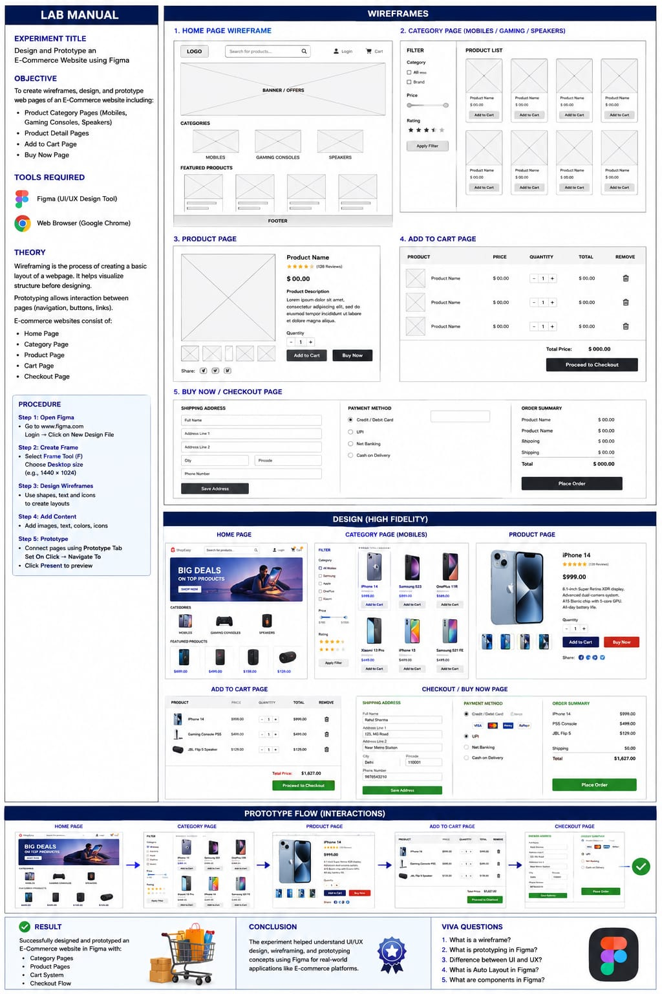
9)Educational Website: Create a wireframe, Design and Prototype the Ul for an educational website Include a Homepage with footer, About Us Page, Programs page, Instructors page, Pricing page, Payments page with radial buttons. Design dropdowns for programs button
Objective
To create wireframes, design, and prototype an educational website including:
Homepage (with footer)
About Us Page
Programs Page (with dropdown)
Instructors Page
Pricing Page
Payments Page (with radio buttons)
Tools Required
Figma
Web Browser (Chrome)
Theory
Wireframing is a basic visual guide representing the structure of a website.
UI Design focuses on layout, colors, typography, and user interaction.
Prototyping connects different pages and simulates real-time navigation.
Educational websites include structured navigation such as:
Course listings
Instructor details
Pricing plans
Secure payment systems
Procedure
Step 1: Open Figma
Go to Figma Official Website⁠�
Login → Click New Design File
Step 2: Create Frames
Use Frame Tool (F)
Select Desktop size (1440 × 1024)
Create separate frames for each page
Wireframes
1. Homepage Wireframe
Header: Logo | Home | About | Programs | Instructors | Pricing | Login
Banner section with heading and CTA button
Features section (icons + text)
Footer:
About links
Quick links
Contact details
2. About Us Page
Company introduction
Mission and Vision
Image section
Footer
3. Programs Page (Dropdown Design)
Programs button with dropdown:
Engineering
Management
Data Science
Design
Languages
Program cards:
Image
Title
Description
4. Instructors Page
Instructor cards:
Photo
Name
Expertise
Social icons
5. Pricing Page
Plans:
Basic
Standard
Premium
Each includes:
Price
Features
Select Button
6. Payments Page (Radio Buttons)
Select Payment Method:
Credit/Debit Card
PayPal
UPI
Net Banking
Wallet
Input fields:

Cardholder Name
Card Number
Expiry Date
CVV
Button: Pay Now
Design Steps
Add colors and typography
Insert images and icons
Use Auto Layout for alignment
Maintain spacing and consistency
Create reusable components
Prototype Steps
Open Prototype Tab
Link pages:
Homepage → About
Homepage → Programs
Programs → Instructors
Pricing → Payments
Add interaction:
On Click → Navigate To
Click Present to preview
Result
Successfully designed and prototyped an educational website with:
Structured navigation
Dropdown menus
Instructor and pricing sections
Payment system with radio buttons
Conclusion
The experiment helped understand wireframing, UI design, and prototyping concepts using Figma. It also improved skills in designing real-world educational platforms.
Viva Questions
What is a wireframe?
What is the purpose of a dropdown menu?
Difference between UI and UX?
What are radio buttons used for?
What is prototyping in Figma?

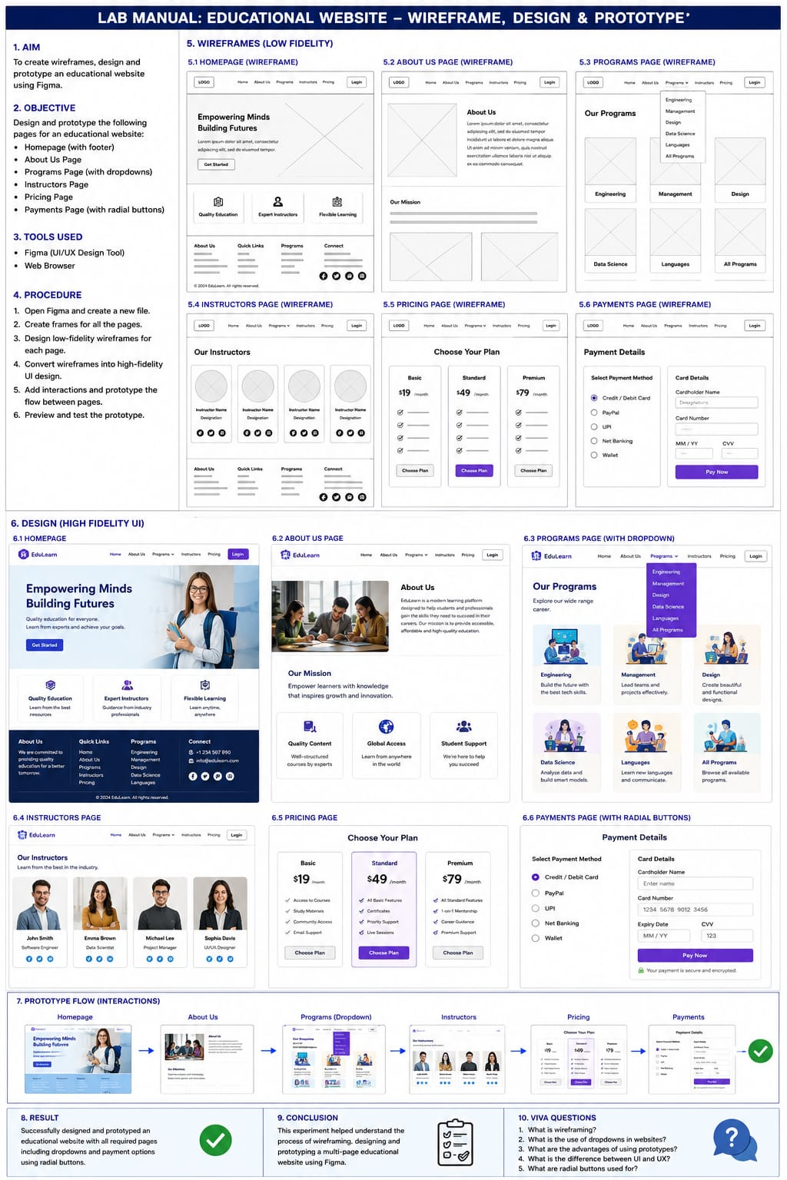

10) Educational Website: Create a wireframe, Design and Prototype the Ul for an educational website Include a Homepage with footer, About Us Page, Programs page, Instructors page, Pricing page, Payments page with radial buttons. Design dropdowns for programs button
1. Aim
To design and prototype a Music Player App that includes:
Home Page with background and rollover buttons
Song Selection Page with Home rollover button
Music Player Page with animations (Play/Pause, Timer, Music animation)
2. Objective
To understand UI/UX design principles
To create wireframes using design tools (e.g., Figma)
To apply interactive components like rollover buttons and animations
3. Tools Required
Figma / Adobe XD / Sketch
Computer System
4. Theory
A Music Player App UI consists of multiple screens that allow users to:
Browse songs
Select music
Control playback
Key UI Elements:
Wireframe (basic layout structure)
Prototype (interactive model)
Rollover Button (changes on hover)
Animations (Play/Pause, Timer)
5. Procedure
Step 1: Create Wireframe – Home Page
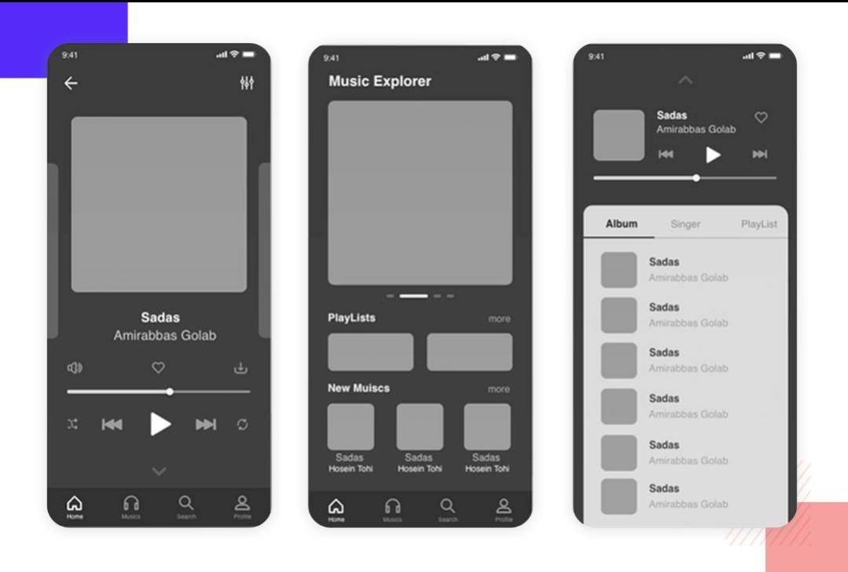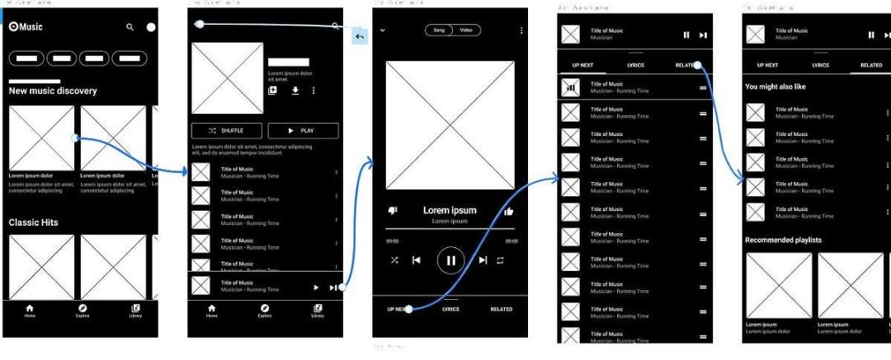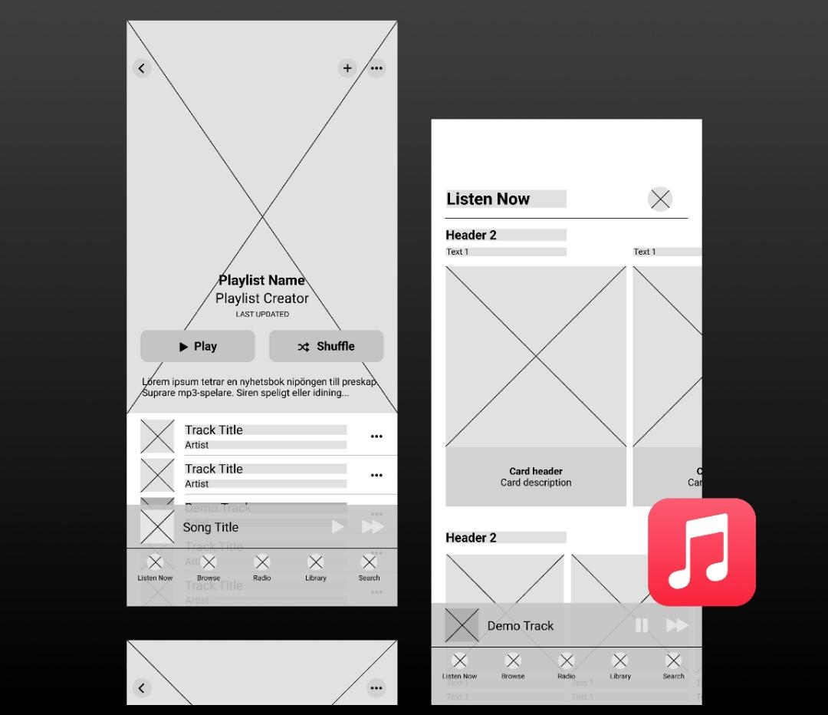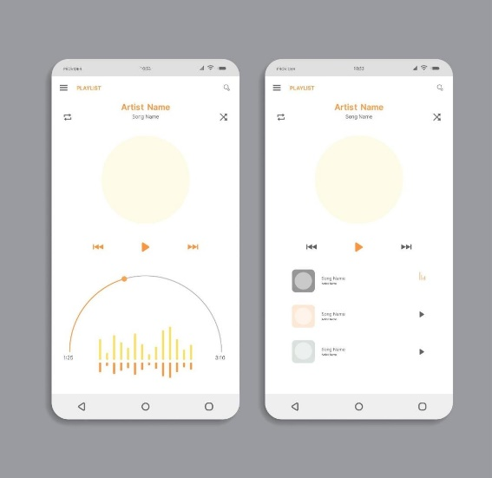
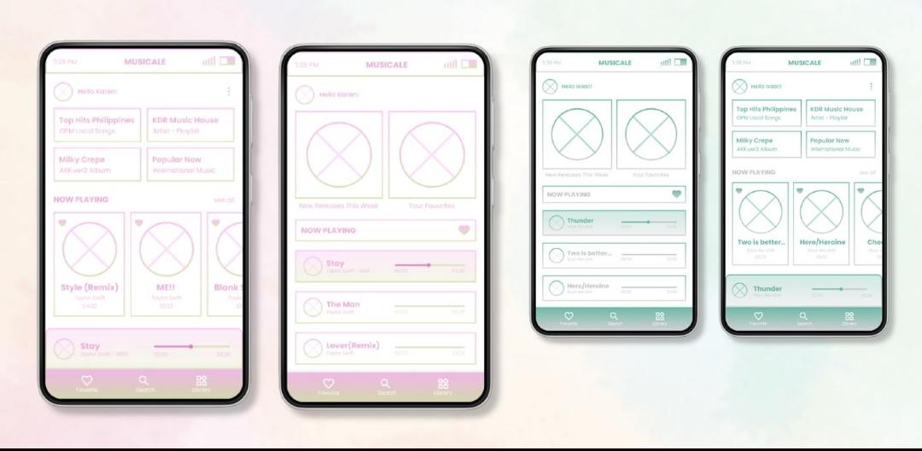
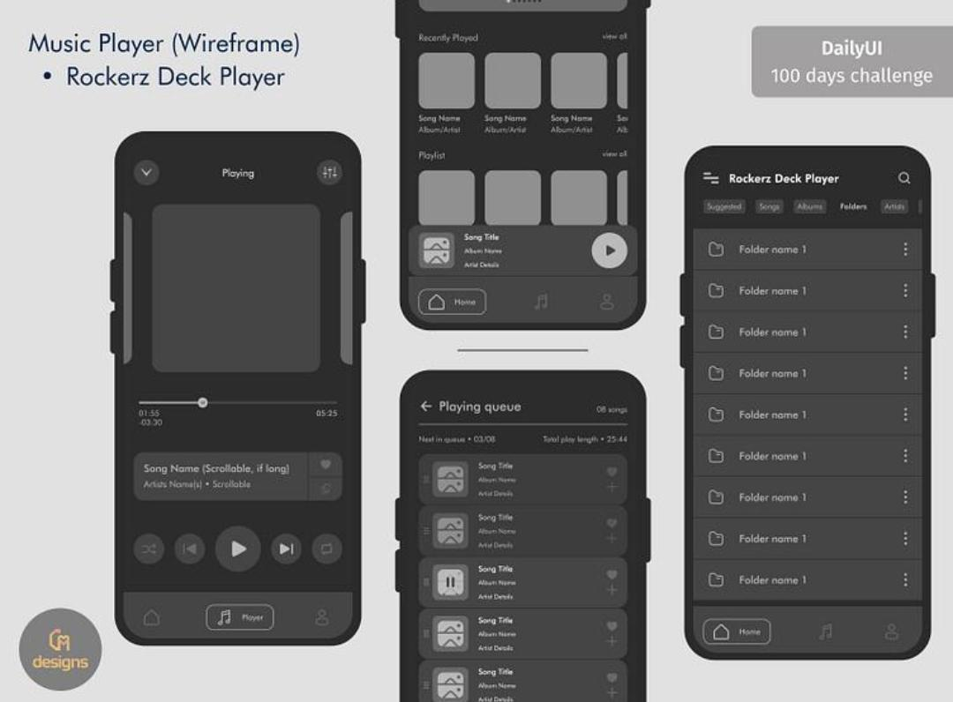
Open Figma
Create a mobile frame
Add:
App Title (Music Player)
Background image
Play / Start Button
Convert button into Rollover Button
Change color on hover
Step 2: Design Song Selection Page
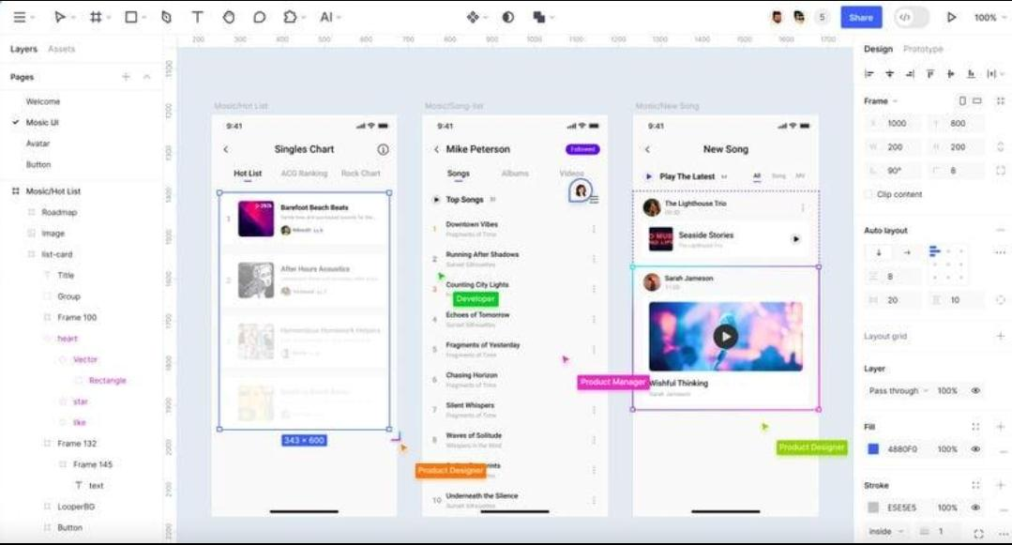
Add list of songs:
Song Name
Artist Name
Add:
Album thumbnails
Scrollable list
Add Home Button (Rollover effect)
On hover → highlight button
Link songs to next page (prototype linking)
Step 3: Create Music Player Page
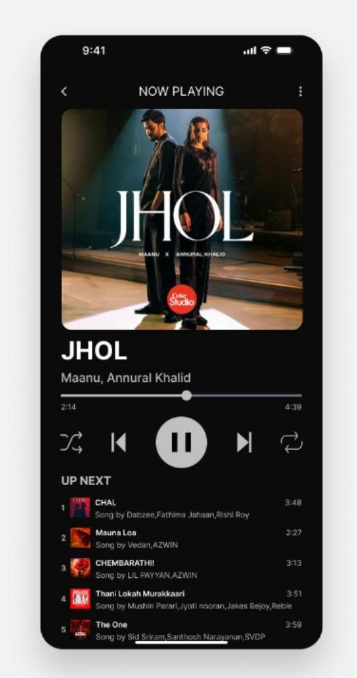
Add:
Song Title
Album Image
Add Controls:
Play / Pause button
Next / Previous
Add Animations:
Play button → transforms into Pause
Music wave animation
Timer progress bar animation
Step 4: Add Prototype Connections
Link Home → Song Selection
Song Selection → Player Page
Add interactions:
On Click → Navigate
Smart Animate → Smooth transition
Step 5: Testing
Run prototype mode
Check:
Button hover effects
Navigation flow
Animation smoothness
6. Result
The Music Player App was successfully designed with:
Wireframe layouts
Interactive rollover buttons
Animated music player interface
7. Conclusion
This experiment helped in:
Understanding UI/UX design
Creating interactive prototypes
Implementing animations and navigation
8. Viva Questions
1. What is a wireframe?
2. What is a prototype?
3. What is a rollover button?
4. What are UI animations?
5. What is Smart Animate in Figma?

